# Lab: Dependency Inversion and Interface Segregation Principles

Problems for exercises and homework for the ["Java OOP Advanced" course @ SoftUni](https://softuni.bg/courses/java-oop-advanced).

# Part I: Dependency Inversion

## System Resources

You are given a GreetingClock. It has the following behavior:

* if hour < 12, prints **"Good morning…"**
* if hour < 18, prints **"Good afternoon…"**
* else prints **"Good evening…"**

Refactor the code so that it conforms to the Dependency Inversion principle.

* Optional: Introduce **Strategy Design Pattern**

### Solution

Create a new interface TimeProvider that has a single method getHour():int

Create an implementation of the interface that can provide the hour (You can use LocalTime java class)

Inject TimeProvider through the clock's constructor

Create a new interface Writer that has a single method println(String):void

Create an implementation that uses a class that can print to the console

Inject Writer through the clock's constructor and use it to write to the console

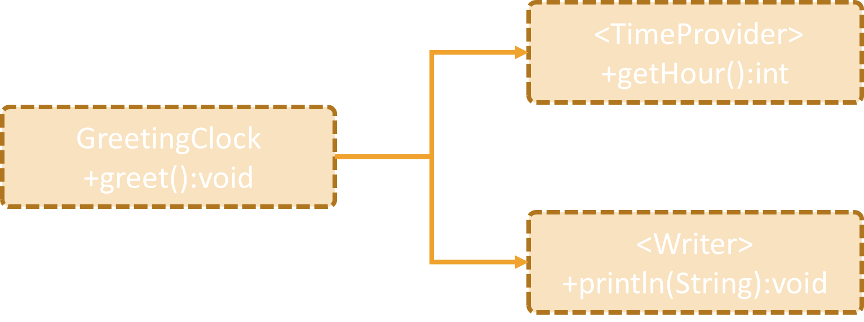

## Services

You are given some classes:

* OnlineStoreOrder
* SmsNotificationService
* EmailNotificationService

Once the order is **processed** it should **send** the proper **notifications** through the services, if they are active.

Refactor the classes so that they conform the Dependency Inversion principle

* Optional: Introduce **Composite Design Pattern**

### Solution

Introduce a new interface called NotificationService and make all notification services to implement it

Either inject variable number of parameters in the OnlineStoreOrder or create a CompositeNotificationService implementation

CompositeNotificationService should implement NotificationService

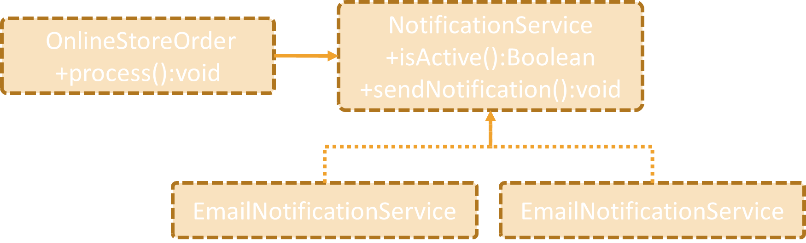

## Employee Info

You are given the classes:

* Employee
* EmployeeInfoProvider
* EmployeeDatabase
* ConsoleFormatter

EmployeeInfoProvider **provides a list of employees to be formatted to a** String **by the** ConsoleFormatter**. Then the string is printed to the console.** Refactor the classes and the structure to conform to the **Dependency Inversion** principle.

### Hints

Create an abstraction between every layer of the application

Create a ConsoleClient which will run the application. Define the abstractions by using as a guide the ConsoleClient's needs (It needs some kind of Formatter and some kind of InfoProvider)

EmployeeInfoProvider needs a database, so define abstraction by looking at what methods EmployeeInfoProvider needs

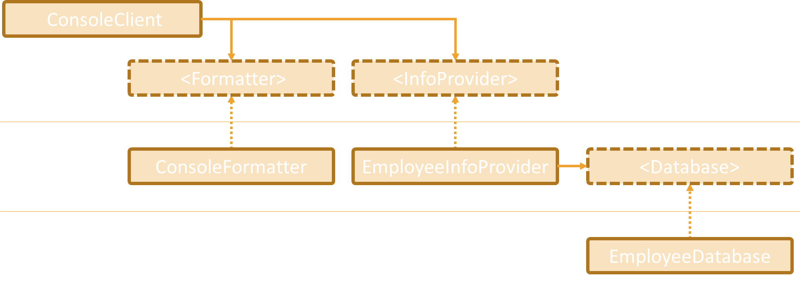

# Part II: Interface Segregation

## Recharge

You are given a library with the following classes

* Worker implements Sleeper
* Employee extends Worker
* Robot extends Worker
* RechargeStation

If you inspect the code, you can see that some of the classes have methods that they can't use (throw UnsupportedOpperationException) which is clear indication that the code should be refactored.

Refactor the structure so that it conforms to the **Interface Segregation** principle.

### Hints

Make the Robot to extend Worker and at the same time to implement Rechargeable

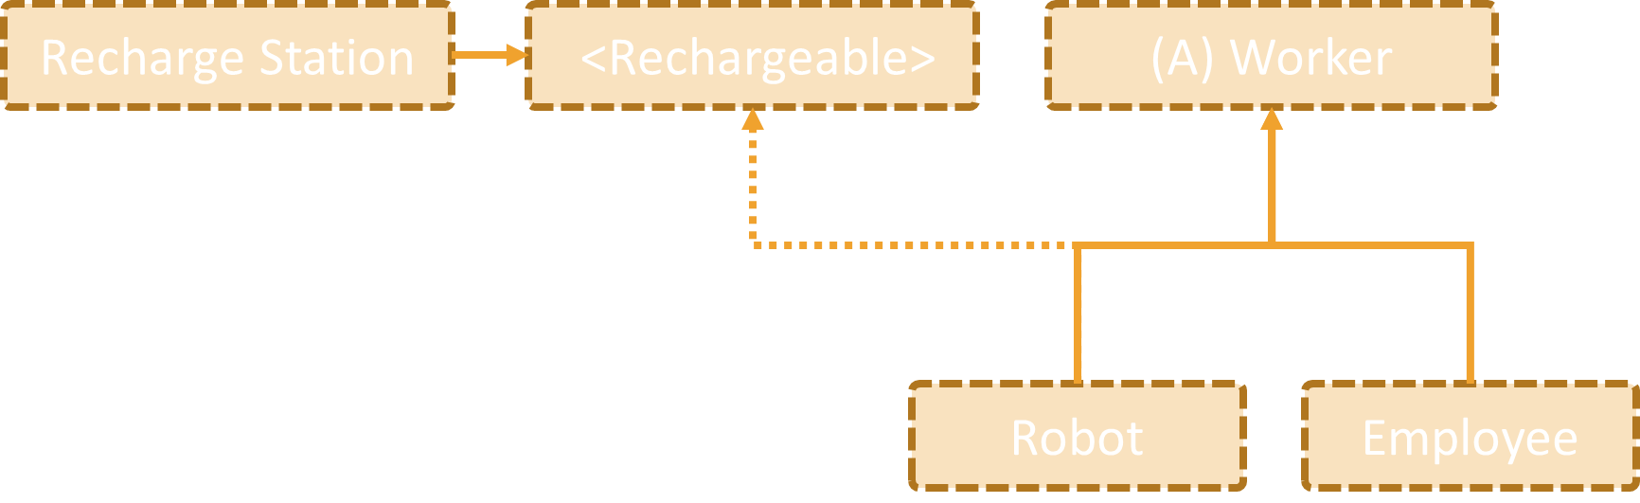

## Security Door

You are given:

* SecurityManager
* abstract class SecurityCheck
* interface SecurityUI

SecurityManager which can interact with a user by validating his key card or by getting his pin code. Both methods are provided by an interface called SecurityUI. The validation is performed by the appropriate SecurityCheck class.

Refactor the structure so that it conforms to the **Interface Segregation** principle.

### Hints

Split SecurityUI into smaller role interfaces, one for each SecurityCheck class

